Project Design Phase-II
Data Flow Diagram & User Stories

Date | 19 february 2026
Team ID | LTVIP2026TMIDS46924
Project Name | ShopSmart
Maximum Marks | 4 Marks

Data Flow Diagrams:
A Data Flow Diagram (DFD) illustrates how data moves within the Resolve Now platform. It captures how user interact with the system, how information flows between different components, and where the data is stored.
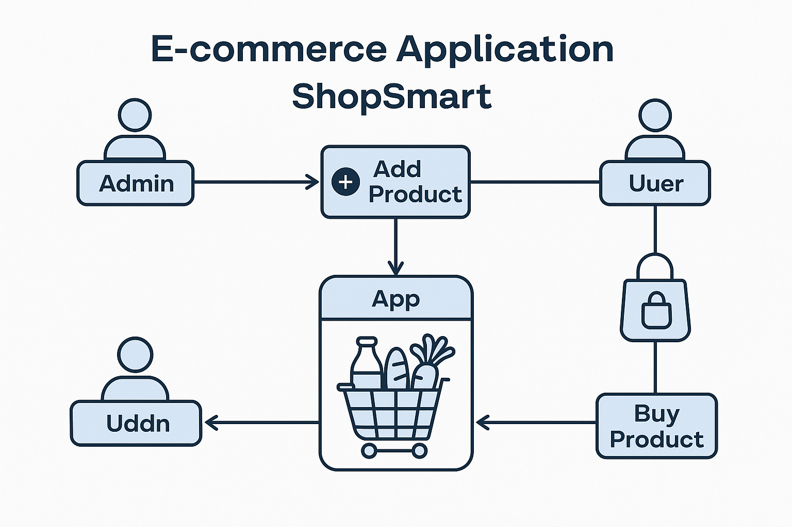

User Story Table – Shop Smart
User Type | Functional Requirement (Epic) | User Story / Task | Acceptance Criteria | Priority | Release
Admin |  | As an admin, I can add new grocery products to the app. | Products appear in the product listing for users. | High | Sprint-1
  Product Management
Admin | Inventory Control |  |  | High | Sprint-1
  As an admin, I can update or delete existing products.
  Changes are reflected in real-time to users.
User |  |  |  | Medium | Sprint-2
  Product Browsing
  As a user, I can browse all available grocery products.
  All listed products are visible with details like price and quantity.
Client |  |  |  | High | Sprint-2
  Add to Cart
  As a user, I can add items to my shopping cart.
  Selected items appear in the cart with correct quantity and total.
Admin |  |  |  | High | Sprint-1
  Order Management
  As an admin, I can view and process user orders.
  Admin dashboard shows new orders and their statuses.

